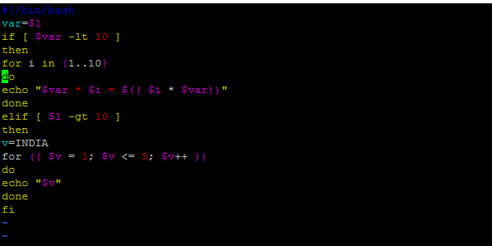

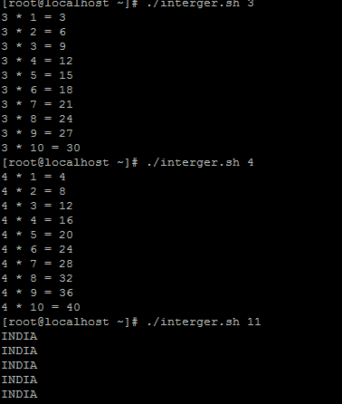

#!/bin/bash
var=$1
if [ $var -lt 10 ]
then
for i in {1..10}
do
echo "$var * $i = $(( $i * $var))"
done
elif [ $1 -gt 10 ]
then
v=INDIA
for (( $v = 1; $v <= 5; $v++ ))
do
echo "$v"
done
fi

